CloudWatch uses the mountains of data constantly being generated by your AWS resources to help you monitor and understand what’s really going on.

Closely monitoring your infrastructure is an integral part of any cloud deployment, and AWS CloudWatch offers a rich set of tools to help. The basic function of any monitoring tool is to collect and help you visualize data so you can take quick and effective action. We should give the same priority to application and server monitoring that we do to High Availability for our applications.

CloudWatch provides infrastructure level monitoring and, to some extent, application monitoring. You can access CloudWatch either from the AWS Console or through API’s and the command line.

CloudWatch monitors metrics describing the behavior of core AWS services within your account. These metrics give you the state of your AWS infrastructure and performance. Every Metric can be made to trigger an alarm, which send notifications to specified end users through AWS’s Simple Notifications Service (SNS).

Cloudwatch offers two levels of monitoring: basic (no charge) and detailed. Basic metrics for some services are automatically applied, and seven pre-selected metrics [are freely available](https://aws.amazon.com/cloudwatch/details/#amazon-ec2-monitoring) for EC2 instances should you choose to enable them. Basic monitoring will generally provide checks every five minutes.

Detailed monitoring offers increased checking at a frequency of every minute, and costs $3.50 per instance per month. We will familiarize you with some of CloudWatch’s great features.

[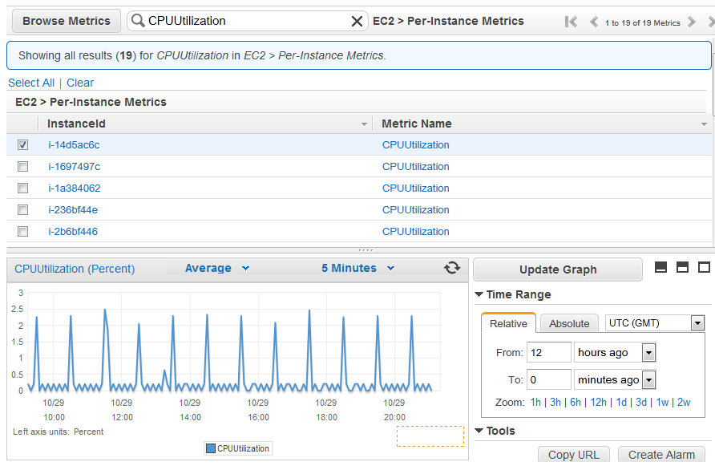](https://d2f9gqwlnfnjcb.cloudfront.net/blog/wp-content/uploads/2015/08/cloudwatch.png)

AWS resources covered by CloudWatch:

Amazon Ec2

EBS Volumes

AutoScaling Groups

Elastic load Balancers

Amazon Route 53

RDS DB instances

DynamoDB tables

ElastiCache clusters

RedShift clusters

SQS queues

SNS topics

Storage Gateways

[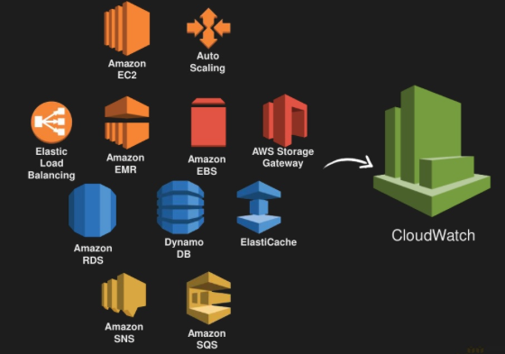](https://d2f9gqwlnfnjcb.cloudfront.net/blog/wp-content/uploads/2015/08/cloudwatch-services.png)

Cloudwatch-Enabled Services

CloudWatch features:

**CloudWatch – Auto Scaling integration**

Auto Scaling lets you automatically scale your servers up and down according to need. You can scale based on schedule, demand, or server hardware utilization. CloudWatch metrics like CPU usage and network utilization can be used to trigger scaling events. For example, suppose your application is running on two instances: you can, say, require one instance to terminate whenever your CPU utilization drops below 60%.

Reboot failed EC2 instances

We’ve shown how CloudWatch can send you notifications using AWS’s SNS. It can also be told to automatically reboot a failed EC2 instance on a failed status check due to loss of network connectivity, system power, or other software/hardware issues.

Integrate CloudWatch with third party Monitoring and Logging tools

You can integrate CloudWatch with third party monitoring tools like Copperegg, stackdriver, and New Relic. These third-party monitoring tools provide very fine performance monitoring, giving you a clear view of the status of your system processes. You can feed CloudWatch metrics to these services, when can then be displayed on a custom dashboard.

Create Custom Metrics

Besides the default CloudWatch metrics like CPU Utilization, Network traffic, and disk read/writes, you may want to monitor more metrics, like memory utilization. You can easily define your own custom metrics. Once these metrics are available in CloudWatch, you can create alarms that trigger new actions.

AWS provides some additional [monitoring scripts](https://aws.amazon.com/code/8720044071969977) for adding custom metrics. When you install the scripts you can choose to report any desired combination of the following metrics:

Memory Utilization – Memory allocated by applications and the operating system, exclusive of caches and buffers, in percentages.

Memory Used – Memory allocated by applications and the operating system, exclusive of caches and buffers, in megabytes.

Memory Available – System memory available for applications and the operating system, in megabytes.

Disk Space Utilization – Disk space usage as percentages.

Disk Space Used – Disk space usage in gigabytes.

Disk Space Available – Available disk space in gigabytes.

Swap Space Utilization – Swap space usage as a percentage.

Swap Space Used – Swap space usage in megabytes.

VPC Flow Logs

[Flow Logs](https://aws.amazon.com/blogs/aws/vpc-flow-logs-log-and-view-network-traffic-flows/) have been available on AWS for only a couple of months. You can tell Flow Logs to track all inbound and outbound traffic moving through selected interfaces attached to your VPC. VPC flow Logs make it much easier to debug issues, like why you are not able reach particular instance.

You can also create CloudWatch metrics and alarms tied to network Flow Logs.